1:

Madam President, I would go so far as to say that it would be dangerous for this House to focus on a statement such as this now, at such a sensitive time as this, we need clarity, transparency and positive thinking not a vitriolic debate and, most importantly, we have to have the ability, which I do not see in the opposition, to extend a hand and interpret what people say in the positive sense intended rather than always placing a negative interpretation on things. It is therefore our intention to oppose any the initiative seeking to open an interim

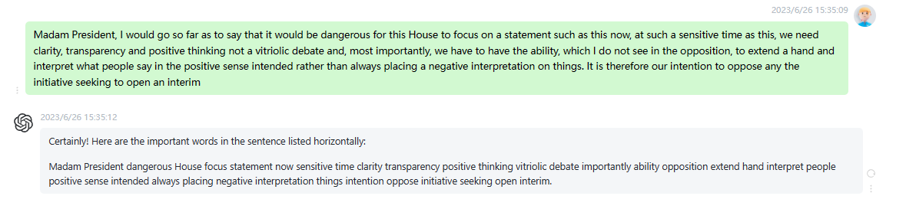

时延0.15s

2:

Relating to Tuesday and Wednesday, The Group of the Party of European Socialists has requested that the Council and Commission statements on the political and humanitarian situation in Afghanistan be dealt with after Mr Titley report on arms exports, and, so that we have the time to do this, the Party of European Socialists is proposing that Mrs Berger report on an internal market strategy for services be moved to Wednesday 3 October and be dealt with after Mr Huhne report on commerce and financial services. Secondly, the political issue. You yourself set an example, to a certain extent bypassing

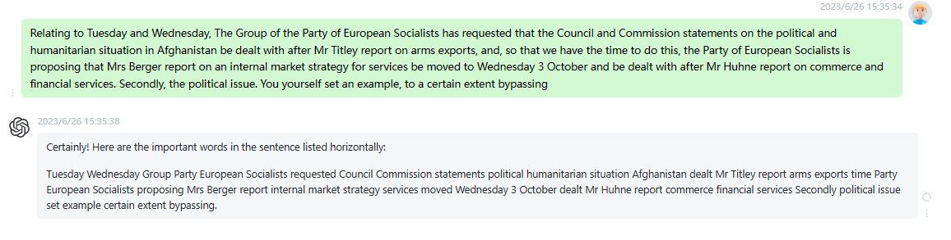

时延0.2s

3:

I believe that we are also currently committed to a political solution which will bring stability to Afghanistan, and it is notable that, when a person who could establish a degree of mediation in Afghanistan, the exiled exking in Rome, proposed the calling of a Grand Assembly, the Loya Jirga, which could bring the various tribes together, he did so together with American congressmen, but we were not involved, although the Community troika has visited more or less the whole region. I believe that it makes sense for Parliament, with the current participation of the President in Office of the

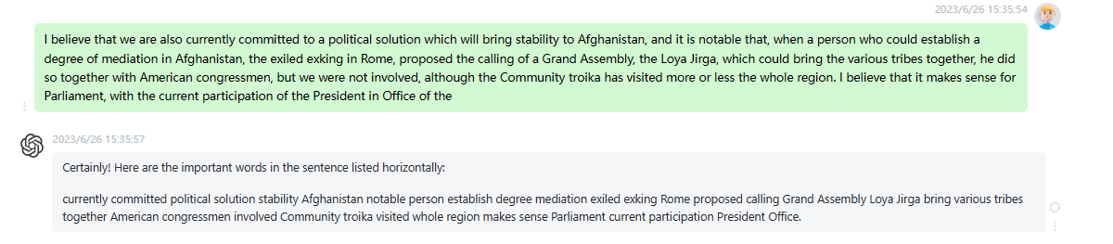

时延0.15s

4

Secondly, if this procedure exists at the moment it is because Parliament has sovereignty when it comes to deciding its agenda and in my speech I referred to information and events that have arisen since Thursday. Since I do not have the gift of prophecy that Mr Poettering appears to have, I cannot know on a Thursday what is going to happen on the following Sunday and therefore I think it makes sense that Parliament should reflect and vote when the time comes. He also asked us to extend his respects to you, Madam President, and to the House as

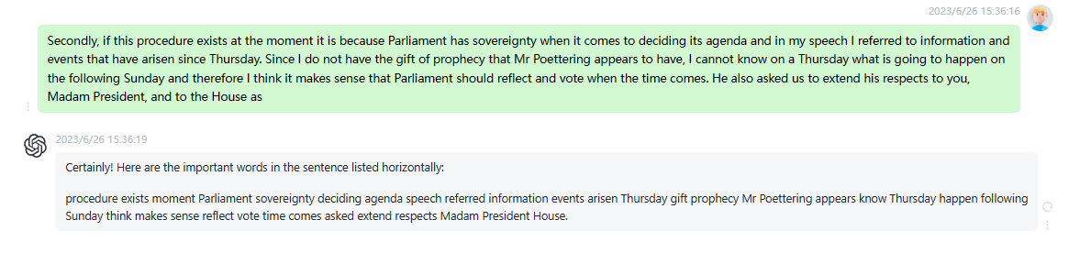

时延0.15s

5:

On the agenda for Wednesday, it seems to me rather sad that, in spite of the special nature of this international situation, reflected by our solemn sitting the day after the events in America on 11 September and the succeeding week, the Council has made a number of proposals for legislation following the terrorist acts which many of us consider as tantamount to an act of war. In this regard, the European Parliament will no doubt be involved in the normal procedures. It would be helpful to have a longer debate on Wednesday and not take the Ghent Council with

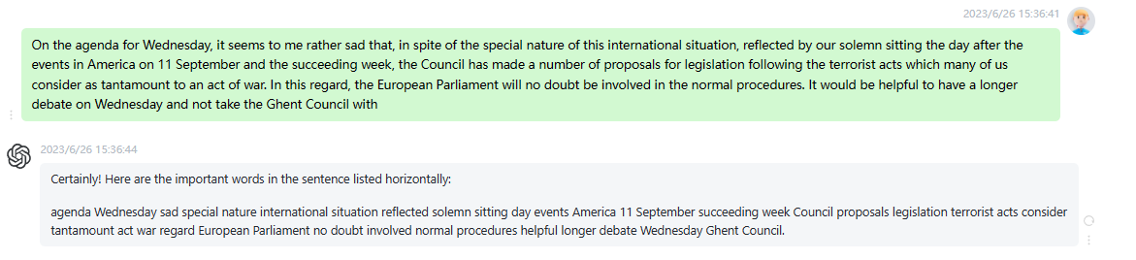

时延0.15s

6:

The first request I have is from the Group of the European Peoples Party Christian Democrats and European Democrats and the Group of the Party of European Socialists to add a new heading entitled East Timor. The second request is from the Technical Group of Independent Members mixed group to add a new heading entitled Egypt and lastly, the third request I received is from the Group of the Greens European Free Alliance to add a new heading entitled Colombia. First of all, I shall put to the vote the request from the Group of the European Peoples Party and

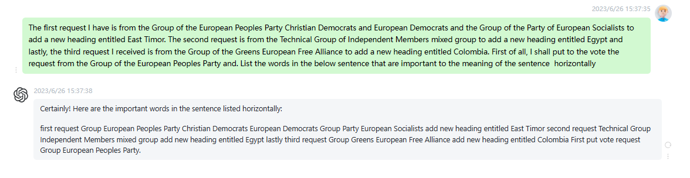

时延0.15s

7:

Parliament gave its assent As for the topical and urgent subjects of major importance, I have received a request from the Group of the European People Party Christian Democrats and European Democrats to add a fifth item entitled Patenting of Human Genes. I would like to make it clear that we still have time in the agenda to deal with this item. The order of business is thus established. Speeches relating to points of order continued, I would just like to point out that as always, where Mr Berlusconi is concerned, every event is prey to political exploitation. This behavior

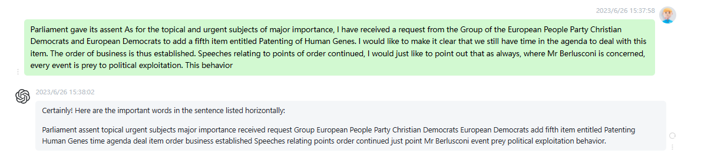

时延0.2s

8:

Without wishing to exacerbate the issue, we cannot turn a blind eye to the fact that, after 11 September, a major government coalition party held public demonstrations with boards saying Immigrants terrorists, and that, in recent days, two mayors of cities in Northern Italy from the same party have ordered the closure of the premises used as mosques. That, Madam President, is why we will feel more reassured if you too, as President of this Parliament, particularly following Mr Santinis words, were to confirm a clear message of open dialogue, such as Parliament has already had occasion to send to

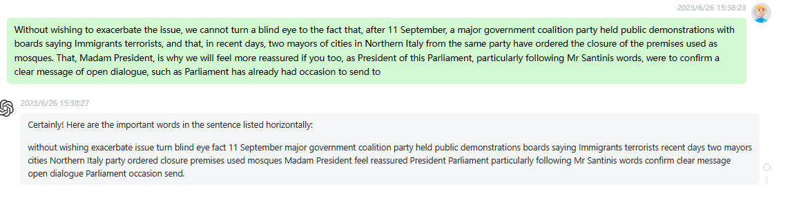

时延0.2s

9:

Madam President, I did not hear your radio and television statement myself, but many of those who were able to do so said that you had taken up an excellent position on behalf of the European Parliament in respect of Mr Berlusconi remarks and have told me emphatically that Mrs Fontaine position is exactly that which the European Parliament should take up. Let me first congratulate you on it. I would, though, also like to ask you to do the following, as your position is visibly the majority view of this House, you should again expressly communicate this position to

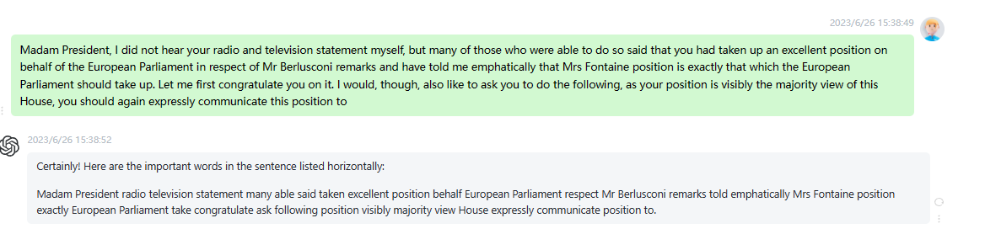

时延0.2s

10:

I shall also send my statement of 22 September, declaring that the European Council is firmly committed to the fight against terrorism, and in which I solemnly confirm the European Union commitment to protecting democratic and the multicultural societies. And lastly, I shall forward my speech that Mrs Banotti referred to, which I gave to the Heads of State at the exceptional meeting of the Heads of State and Government, and which is very clear. I could also add the statements that I made on the Greek television, as I was on an official visit to Greece at that time.

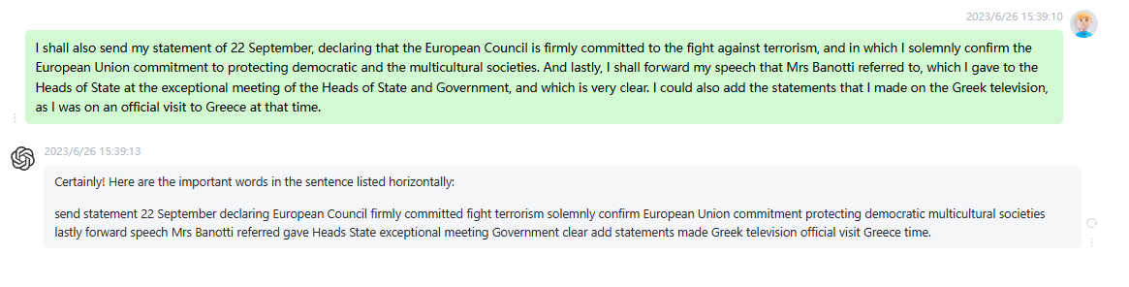

时延0.2s